December 2022 Grab-N-Go Menu

Monday | Tuesday | Wednesday | Thursday | Friday
 |  |  | 01)Chicken Fajita Wrap  Lettuce/Tomato/Cheese  Corn Salad  Cupped Salsa  Grain Chips/Fruit/Milk | 02)  NO  GRAB-N-GO  TODAY
05)Soy Butter & Jelly  Sandwich  Cupped Hummus  Carrots w/Ranch  Grain Chips/Fruit/Milk | 06)Make Your Own Pizza  Cupped Marinara Sauce  Cupped Cheese/Corn Salad  Broccoli w/Ranch  Grain Chips/Fruit/Milk | 07)Grilled Chicken salad  w/Ranch  String Cheese  Grain Chips  Fruit / Choice of Milk | 08)Chicken Fajita Wrap  Lettuce/Tomato/Cheese  Corn Salad  Cupped Salsa  Grain Chips/Fruit/Milk | 09)  NO  GRAB-N-GO  TODAY
12)Soy Butter & Jelly  Sandwich  Cupped Hummus  Carrots w/Ranch  Grain Chips/Fruit/Milk | 13)Make Your Own Pizza  Cupped Marinara Sauce  Cupped Cheese/Corn Salad  Broccoli w/Ranch  Grain Chips/Fruit/Milk | 14)  NO  GRAB-N-GO  TODAY | 15)  NO  GRAB-N-GO  TODAY | 16)  NO  GRAB-N-GO  TODAY
20)  OUT OF  SCHOOL | 21)  OUT OF  SCHOOL | 22)  OUT OF  SCHOOL | 23)  OUT OF  SCHOOL | 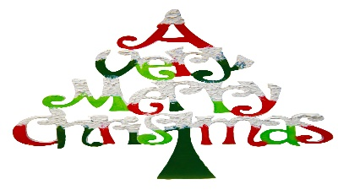
27)  OUT OF  SCHOOL | 28)  OUT OF  SCHOOL | 29)  OUT OF  SCHOOL | 30)  OUT OF  SCHOOL
THIS IS AN EQUAL OPPORTUNITY PROVIDER

