December 2022 Lunch Menu
MENUS ARE SUBJECT TO CHANGE ONLY WHEN ABSOLUTELY NECESSARY
Monday | Tuesday | Wednesday | Thursday | Friday
 |  |  | 01)Homemade Taco Soup  Grilled Cheese Sandwich  Tortilla Chips w/Salsa  Raw Carrots w/Ranch  Cookie / Fruit / Milk | 02) Variety of Pizza  Garden Salad w/Ranch  Corn Nuggets  Fruit  Choice of Milk
05) Chicken Fingers  Creamed Potatoes  Pinto Beans  Roll  Fruit / Choice of Milk | 06) Scramble Eggs  w/Sausage Links  Tator Tots / Biscuits  Sliced Tomatoes  Fruit / Choice of Milk | 07) Cheese Sticks  w/Marinara Sauce  Garden Salad w/Ranch  Glazed Carrots  Fruit / Choice of Milk | 08) Homemade  Chicken Noodle Soup  Grilled Cheese Sandwich  Raw Carrots w/Ranch  Cookie / Fruit / Milk | 09) Corn Dog  French Fries  Coleslaw  Fruit  Choice of Milk
12) Crispitos  w/Chili & Cheese  Corn on the Cob  Cheesy Refried Beans  Fruit / Choice of Milk | 13) Variety of Pizza  Garden Salad w/Ranch  Steamed Carrots  Fruit  Choice of Milk | 14) Hamburger  Lettuce/Tomato/Pickles  French Fries  Coleslaw  Fruit / Choice of Milk | 15)Breaded Chic Sandwich  w/Lettuce & Tomato  Broccoli w/Ranch  Sun Chips w/Salsa  Fruit / Choice of Milk | 16)Turkey & Cheese Sub  w/Lettuce & Tomato  Raw Carrots w/Ranch  Sun Chips w/Salsa  Fruit / Choice of Milk
20)  OUT OF  SCHOOL | 21)  OUT OF  SCHOOL | 22)  OUT OF  SCHOOL | 23)  OUT OF  SCHOOL | 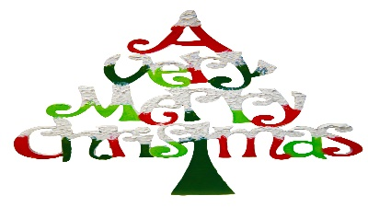
27)  OUT OF  SCHOOL | 28)  OUT OF  SCHOOL | 29)  OUT OF  SCHOOL | 30)  OUT OF  SCHOOL
THIS IS AN EQUAL OPPORTUNITY PROVIDER

